Teams Room Setup

**Create Office 365 resource mailbox in Exchange Admin Center**

# On Exch04

Log into the Exchange Admin Center (EAC) with admin privileges. This is on the Exch04 on-premises server and **NOT** Office 365. Click **recipients** in the feature pane and click **mailboxes** in the tabs. Click the + icon. Select **Office 365 mailbox** to create a new mailbox in Office 365.

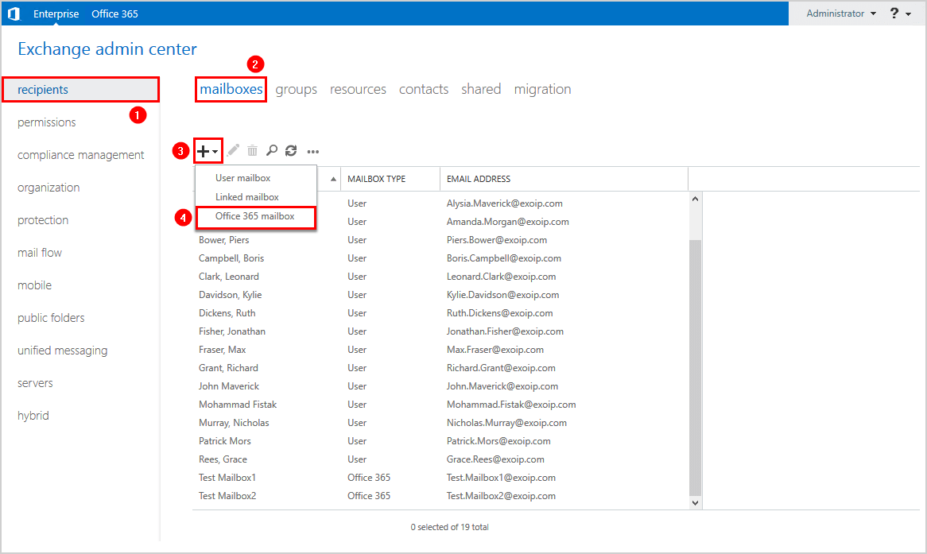

Fill in the information. Ensure that you select a verified domain UPN suffix and not a local suffix such as .local or .lan. Select **Room mailbox** for Mailbox type. Click **Save**.

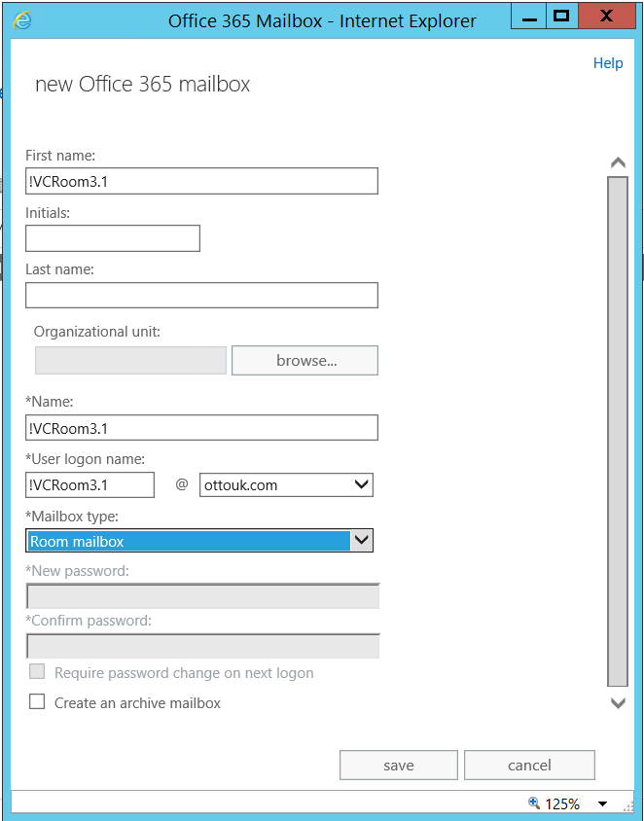

After creating the room mailbox, you need to use AD Tools to move it into the correct OU:

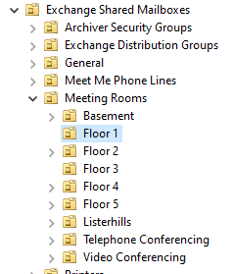

Only certain OUs sync with Azure/O365.  The default that it creates new mailboxes in, isn’t one that syncs.

Don’t forget to [force sync Azure AD Connect](https://www.alitajran.com/force-sync-azure-ad-connect-with-powershell/) or wait a maximum of 30 minutes before the sync is automatically run.

PS C:\> Start-ADSyncSyncCycle -PolicyType Delta

It can still take 30 mins, so be patient……….

Click on the new room mailbox and click the **edit** icon in the toolbar.

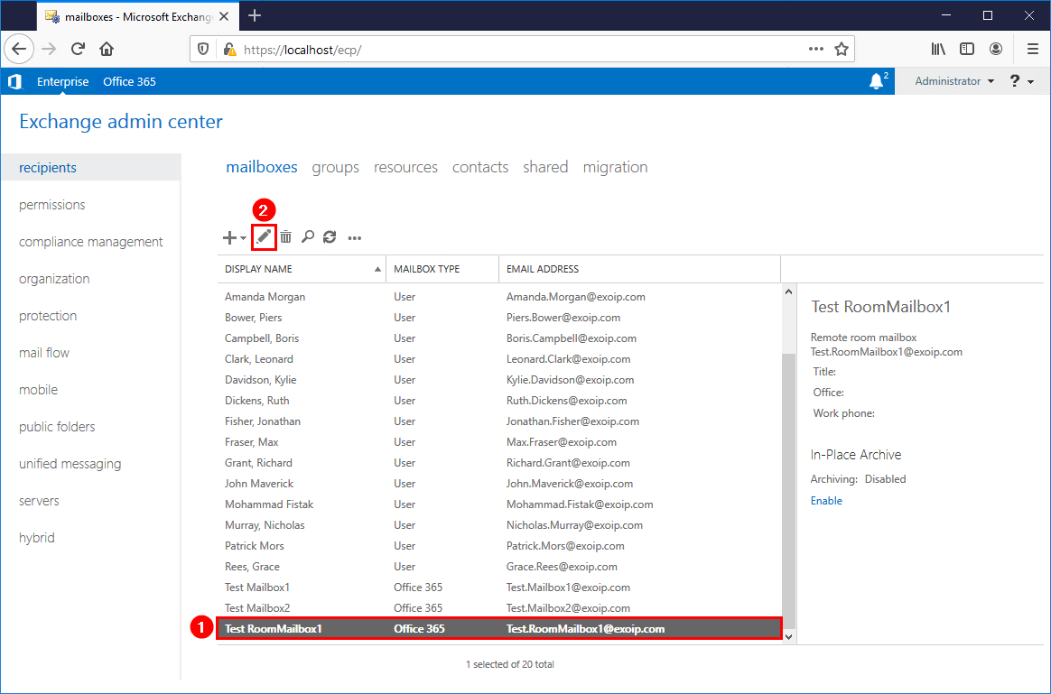

Click **email address** in the menu. Verify that you see:

1. smtp:@FreemansGrattanHoldings.mail.onmicrosoft.com
2. Remote routing address

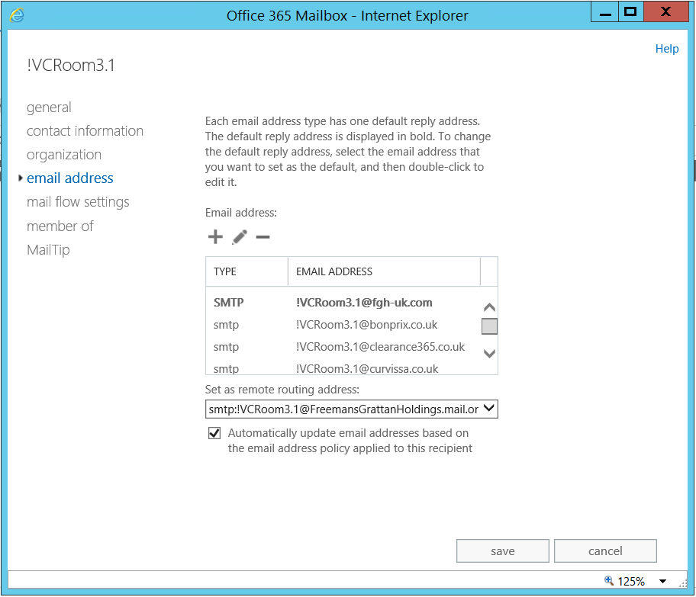

# In O365 Admin

Log in with your Microsoft 365 admin credentials. Go to **recipients** > **resources**. Click the Office 365 room mailbox and press the edit icon in the toolbar.

You will only see Office 365 mailboxes in Microsoft 365 Exchange admin centre. The on-premises mailboxes are not shown on Microsoft’s cloud servers.

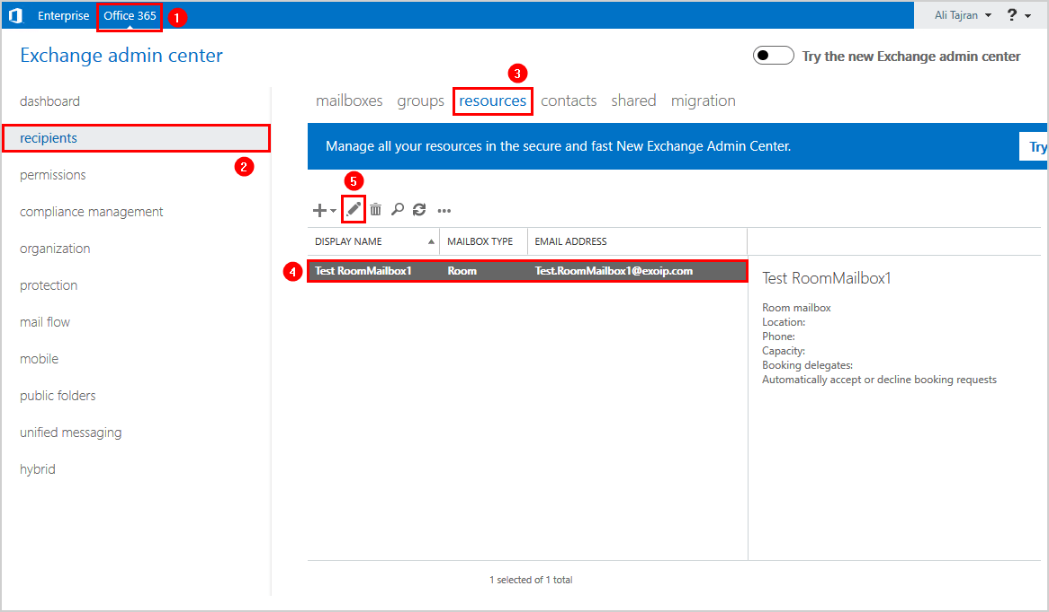

In the menu, click on **email address**. There is no remote routing address option in the cloud, and you will see two smtp **onmicrosoft.com** email addresses:

1. smtp:@ FreemansGrattanHoldings.mail.onmicrosoft.com
2. smtp:@ FreemansGrattanHoldings.onmicrosoft.com

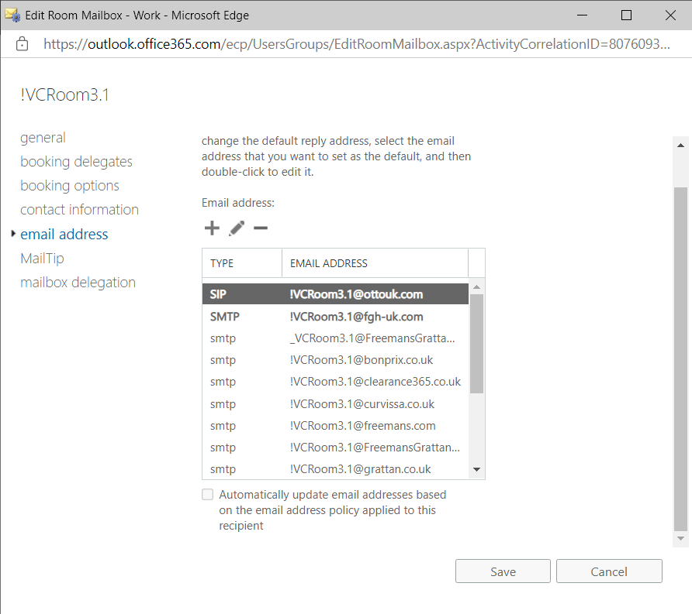

# On Prem AD

In Active Directory Users and Computers, the AD-object shows up. As I didn’t put any Organisational Path in earlier, it will be in the Users OU. I then moved it to the Exchange Shared mailboxes\ Meetng Rooms\Video Conferencing.

I then enabled it and set a password.

I also put the computer object in the same OU so that I could block group policy to them both.

# On The Logitech Console

Runs Windows 10

Log in as admin

Pw=sfb

Add new user to local admins group.

Launch teams Rooms.

Go to settings and reset.

Go through adding the new user wizard.

Add email address. [user@fgh-uk.com](mailto:user@fgh-uk.com).

Add password.

Add domain logon account. user@ottouk.com

### Create Office 365 resource mailbox with Exchange Management Shell

Run Exchange Management Shell as administrator. Make use of the [New-RemoteMailbox](https://docs.microsoft.com/en-us/powershell/module/exchange/new-remotemailbox?view=exchange-ps) cmdlet. Run the command to create a resource mailbox in Office 365.

[PS] C:\>New-RemoteMailbox -Room -Name "Test RoomMailbox2" -Firstname "Test" -LastName "RoomMailbox2" -UserPrincipalName "Test.RoomMailbox2@exoip.com" -OnPremisesOrganizationalUnit "OU=Resources,OU=Company,DC=exoip,DC=local"

Copy

Wait for Azure Active Directory synchronization or [force sync Azure AD connect with PowerShell](https://www.alitajran.com/force-sync-azure-ad-connect-with-powershell/).

PS C:\> Start-ADSyncSyncCycle -PolicyType Delta

Copy

The room mailbox shows up in Exchange admin center.

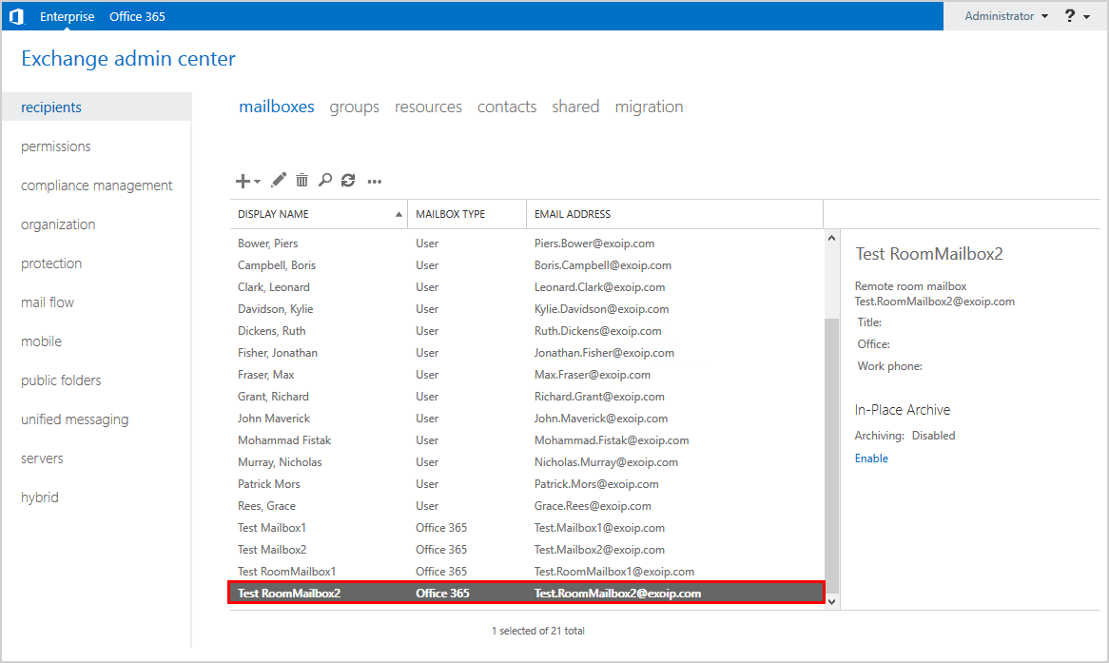

Click in the top bar on Office 365. Go to **recipient > resources**. Verify that you see the room mailbox.

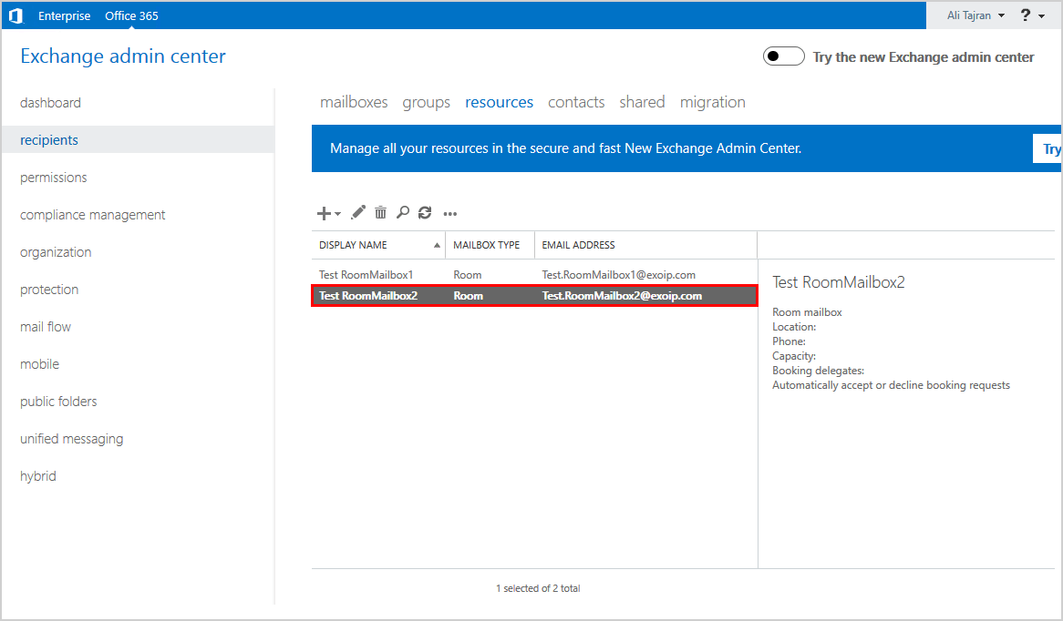

## Test room mailbox booking

We did create two Office 365 resource (room) mailboxes. Let’s test booking a room mailbox.

Log in to Amanda’s Outlook, which is an on-premises mailbox. Click on **New items > Meeting**.

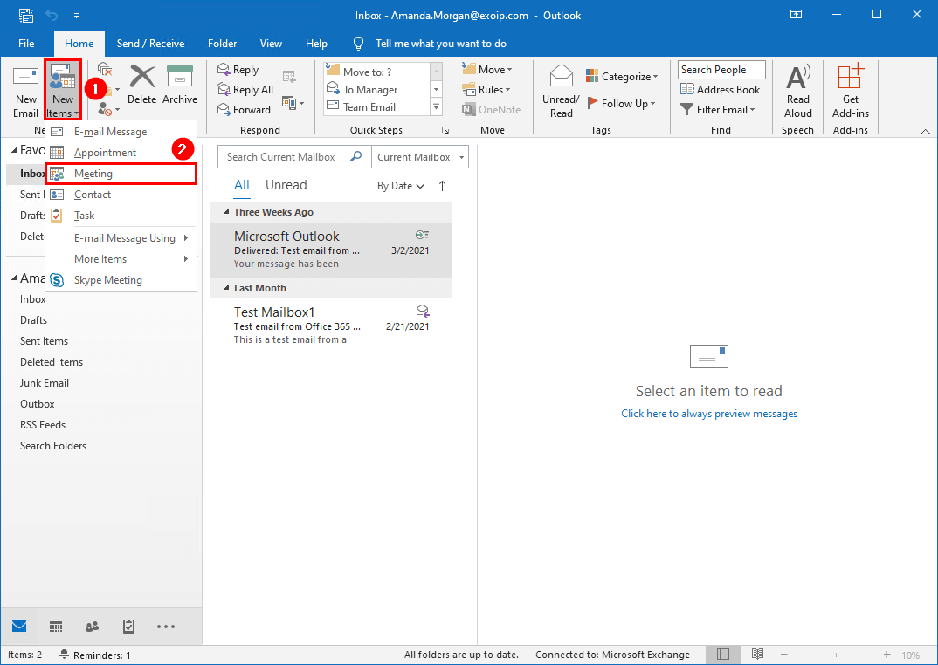

Fill in the user you want to send the invite to and include the test room mailbox that you created in the earlier step. Click **Send**.

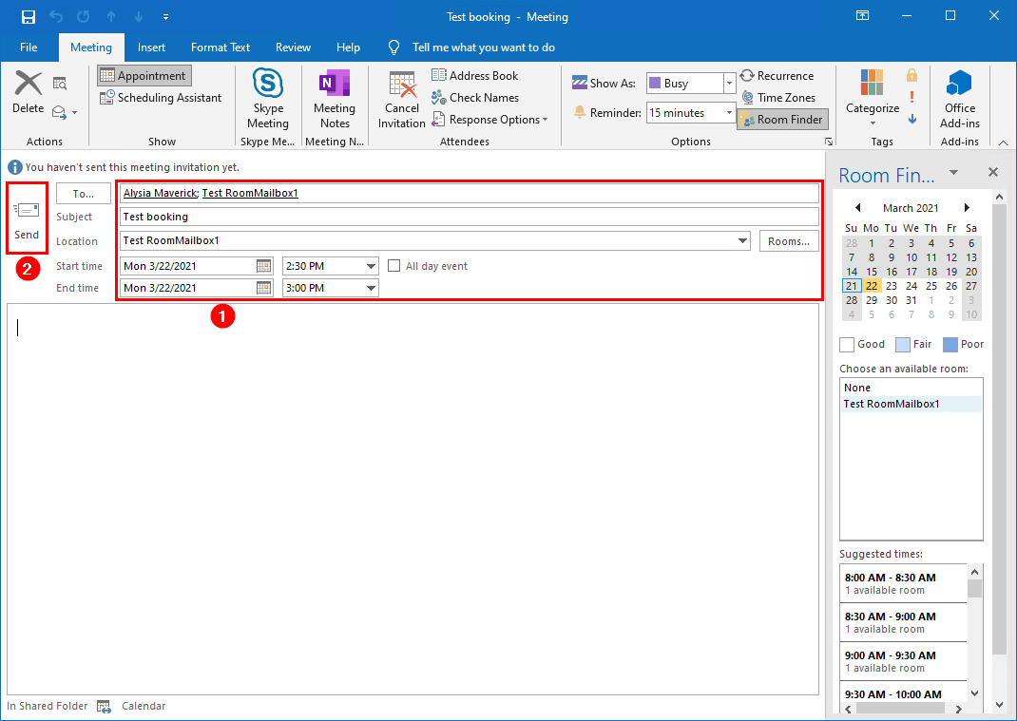

The meeting request is automatically accepted because that is the default behavior for new room mailboxes.

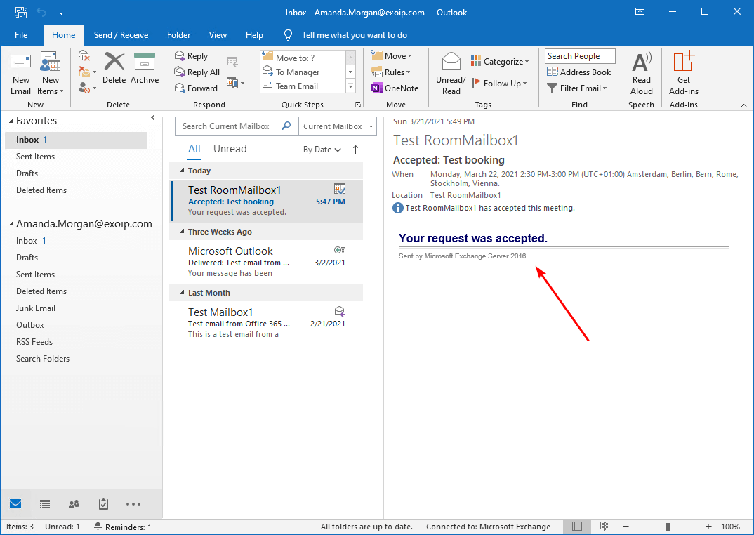

## Test GAL visibility in both organizations

It’s good to test the Global Address List (GAL) visibility in Exchange on-premises and Exchange Online (Office 365).

### Exchange on-premises Global Address List visibility

From Amanda’s Outlook client, click on **Address Book**. Select the address book **All Rooms**. Verify that the Office 365 room mailboxes show up.

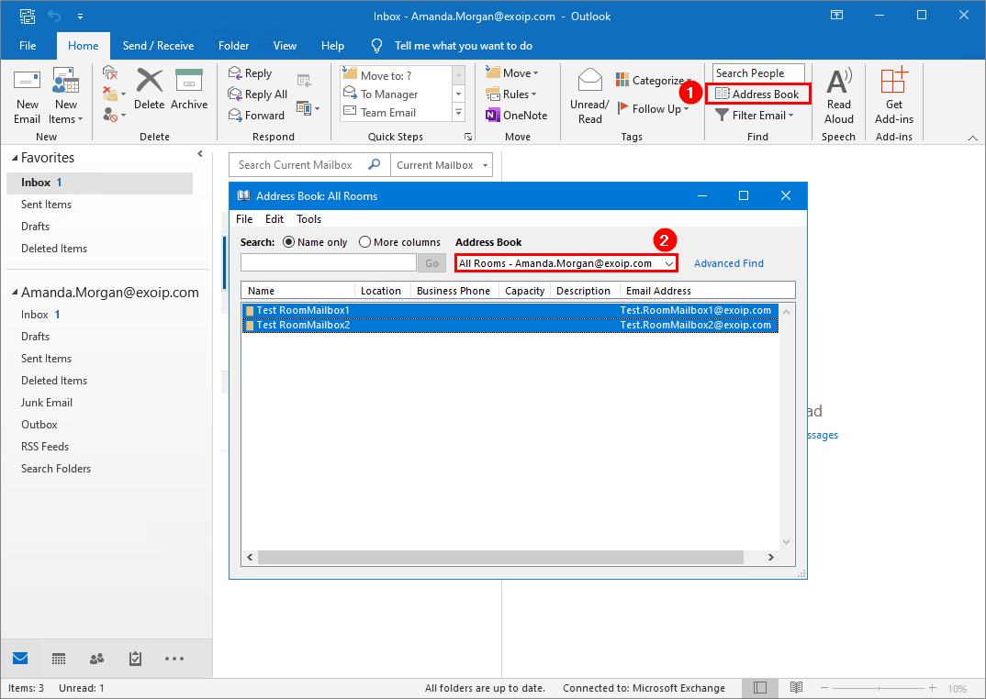

### Office 365 Global Address List visibility

From Test Mailbox1 Outlook client, click on **Address Book**. Select the address book **All Rooms**. Verify that you see the Office 365 room mailboxes.

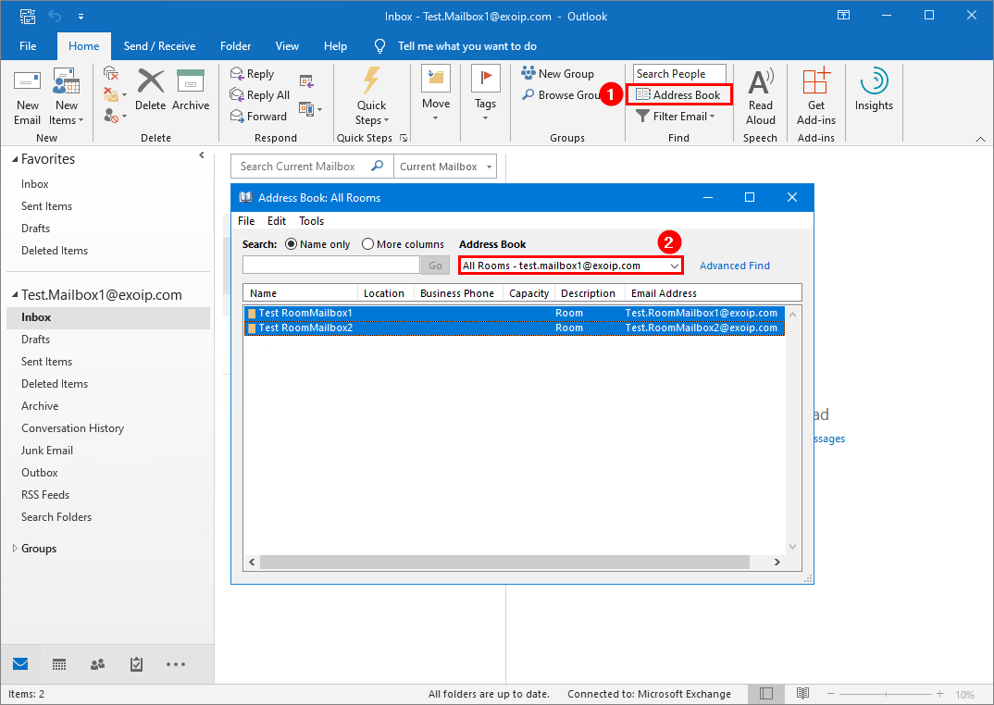

The next time, we will look at how to [create distribution group in Exchange hybrid](https://www.alitajran.com/create-distribution-group-exchange-hybrid/).

## Conclusion

In this article, you learned how to create an Office 365 resource mailbox in Exchange hybrid configuration. There are a couple of options to create a room mailbox in Office 365. Choose the one that works best for you.